Experiment No. 12

Lab 12 – Introduction

Exercise:

Q.1 Create a list of different Cities of Pakistan and by using random module Shuffle that list.

**CODE:**

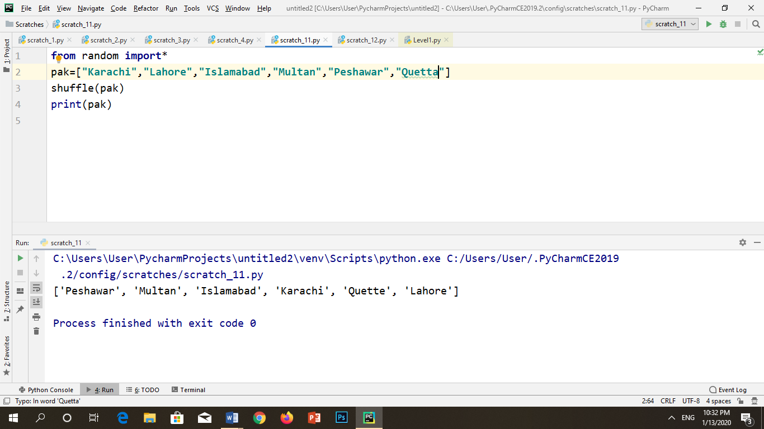

**OUTPUT:**



Q.2 Define a list, consisting of names of different students, who are applying for a scholarship, pop an item from that list and transfer all items in a new list and apply sample method of random module to give scholarship to two students of new list.

**CODE:**

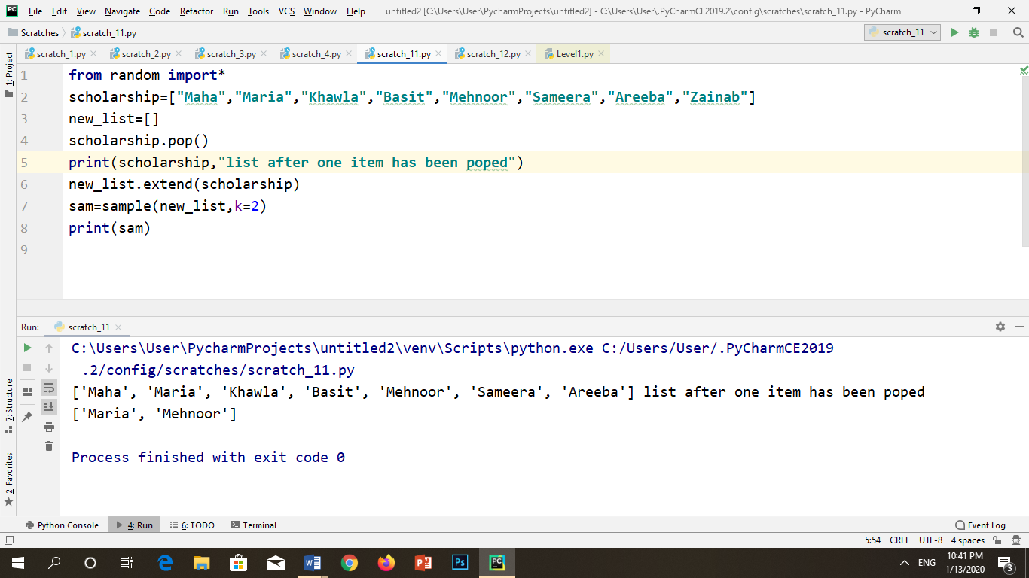

**OUTPUT:**



Q.3 Define two lists dice1 and dice2, holding numbers from 1 to 6 ,Design a python program that start playing with two dices for two players

**CODE:**

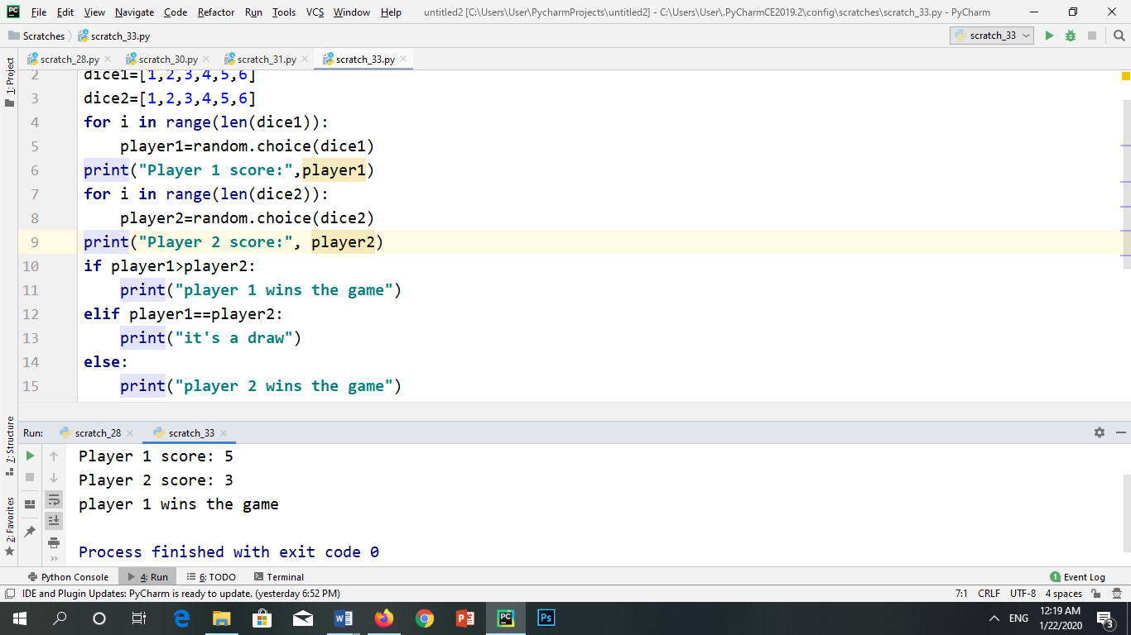

**OUTPUT:**

